**EL:86-371-67169080 FAX: 86-371-67169090**

[**E-mail:sales@hwsensor.com**](mailto:sales@hwsensor.com)

TECHNICAL DATA GAS SENSOR

FEATURES

* High sensitivity to LPG, iso-butane, propane
* Small sensitivity to alcohol, smoke.
* Fast response . * Stable and long life * Simple drive circuit

APPLICATION

They are used in gas leakage detecting equipments in family and industry, are suitable for detecting of LPG, iso-butane, propane, LNG, avoid the noise of alcohol and cooking fumes and cigarette smoke.

SPECIFICATIONS

1. Standard work condition

|  |  |  |  |
| --- | --- | --- | --- |
| Symbol | Parameter name | Technical condition | Remarks |
| Vc | Circuit voltage | 5V±0.1 | AC OR DC |
| VH | Heating voltage | 5V±0.1 | ACOR DC |
| PL | Load resistance | 20KΩ |  |
| RH | Heater resistance | 33Ω±5% | Room Tem |
| PH | Heating consumption | less than 750mw |  |

1. Environment condition

|  |  |  |  |
| --- | --- | --- | --- |
| Symbol | Parameter name | Technical condition | Remarks |
| Tao | Using Tem | -10℃-50℃ |  |
| Tas | Storage Tem | -20℃-70℃ |
| RH | Related humidity | less than 95%Rh |
| O2 | Oxygen concentration | 21%(standard condition)Oxygen  concentration can affect sensitivity | minimum value is  over 2% |

1. Sensitivity characteristic

|  |  |  |  |  |
| --- | --- | --- | --- | --- |
| Symbol | Parameter name | | Technical parameter | Remarks |
| Rs | Sensing | Resistance | 10KΩ- 60KΩ | Detecting concentration |
|  |  | | (1000ppm LPG ) | scope： |
|  |  | |  | 200-10000ppm  LPG , iso-butane, propane,  LNG |
| α |  | |  |
| (1000ppm/ 4000ppm LPG) | Concentration slope rate | | ≤0.6 |
| Standard  detecting condition | Temp: 20℃±2℃ Humidity: 65%±5% | | Vc:5V±0.1 Vh: 5V±0.1 |
| Preheat time | Over 24 hour | | |  |

1. Strucyure and configuration, basic measuring circuit

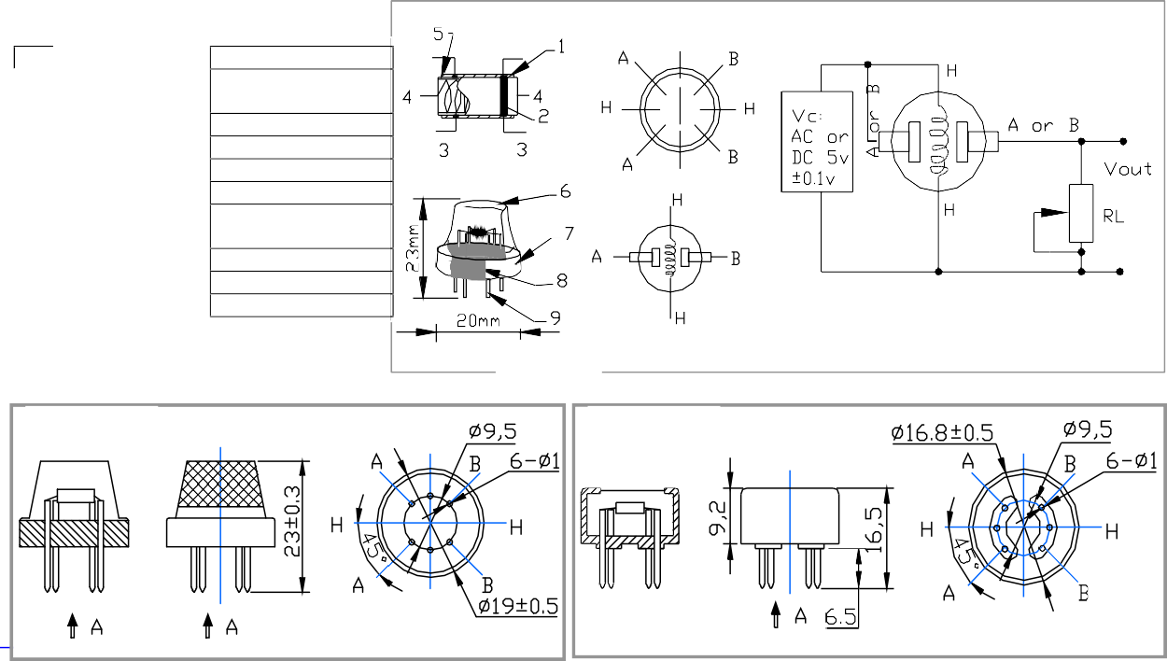

Fig.2

Fig. 1

Configuration **A**

Configuration **B**

**T**

A向

[A](mailto:sales@hwsensor.com)向

Copper plating Ni

Tube Pin

9

Bakelite

Resin base

8

Copper plating Ni

Clamp ring

7

Stainless steel gauze (SUS316 100-mesh)

Anti-explosion network

6

Al2O3

Tubular ceramic

5

Ni-Cr alloy

Heater coil

4

Pt

Electrode line

3

Au

Electrode

2

SnO2

Gas sensing layer

1

Materials

Parts

Structure and configuration of MQ-6 gas sensor is shown as Fig. 1 (Configuration A or B), sensor composed by micro AL2O3 ceramic tube, Tin Dioxide (SnO2) sensitive layer, measuring electrode and heater are fixed into a crust made by plastic and stainless steel net. The heater provides necessary work conditions for work of sensitive components. The enveloped MQ-6 have 6 pin ,4 of them are used to fetch signals, and other 2 are used for providing heating current.

Electric parameter measurement circuit is shown as Fig.2

# Sensitivity characteristic curve

Fig.2 sensitivity characteristics of the MQ-6

Fig.3 is shows the typical sensitivity characteristics of the MQ-6 for several gases.

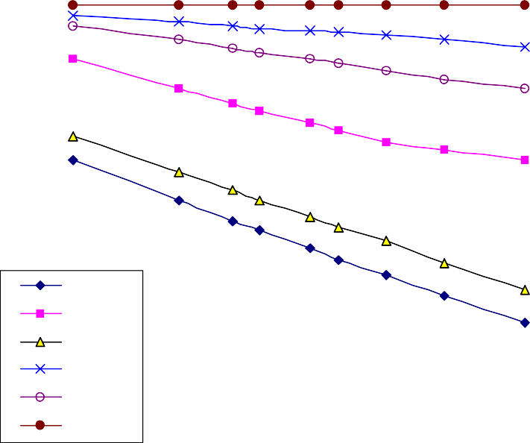

10

MQ-6

1

LPG H2 CH4 CO

Alcohol

Ai r

0. 1

100

1000

ppm

10000

in their: Temp: 20℃、Humidity: 65%、

O2 concentration 21% RL=20kΩ

Ro: sensor resistance at 1000ppm of LPG in the clean air.

Rs:sensor resistance at various concentrations of gases.

Rs/Ro

Fig.4 is shows the typical dependence of the MQ-6 on temperature and humidity.



MQ-6

1. 4

1. 3

1. 2

1. 1

0. 1

33%RH

85%RH

0. 9

0. 8

0. 7

0. 6

5

-10

0

10

20 Temp 30

40

50

Ro: sensor resistance at 1000ppm of LPG in air at 33%RH and 20 degree.

Rs: sensor resistance at 1000ppm of LPG in air at different temperatures and humidities.

Fig.4

Rs/Ro

SENSITVITY ADJUSTMENT

Resistance value of MQ-6 is difference to various kinds and various concentration gases. So, When using this components, sensitivity adjustment is very necessary. we recommend that you calibrate the detector for 1000ppm of LPG concentration in air and use value of Load resistance ( RL) about 20KΩ(10KΩ to 47KΩ).

When accurately measuring, the proper alarm point for the gas detector should be determined after considering the temperature and humidity influence.